**Model Question**

**D-**

**Class: One First Terminal Examination-2082 F.M.: 50**

**Subject: Maths Time: - 2 hrs. P.M.: 18**

**1. Tick the best answer. [10]**

a. There are _______________ days in a week.

i. 7 ii. 10 iii. 4

b. There are _______________ months in a year.

i. 10 ii. 12 iii. 9

c. The first day of a week is _______________

i. Saturday ii. Sunday iii. Tuesday

d. The last day of a week is _______________.

i. Sunday ii. Saturday iii. Thursday

e. _______________ comes just after Sunday.

i. Wednesday ii. Thursday iii. Monday

f. A triangle has _______________ corners.

i. 3 ii. 5 iii. 2

g. _______________ comes between 5 and 7.

i. 4 ii. 6 iii. 8

h. Which month comes between April and June?

i. January ii. May iii. July

i. Which one is an odd number?

i. 1 ii. 4 iii. 8

j. Which one is even number?

i. 5 ii. 6 iii. 7

**2. Look at the picture and fill in the blanks. [2]**

a. A _______________ is sitting between Duck and Cat.

b. A _______________ is sitting in front of Rabbit.

**3. Match the following. [4]**

1 !)

10 !

3 (

9 #

**4. Write the number names in Devnagari. [6]**

a. ! = _______________ b. % = _______________

b. !) = _______________ c. ( = _______________

c. $ = _______________ d. !) = _______________

**5. Write the number names in Hindu Arabic. [6]**

a. rf/ _______________ d. cf7 _______________

b. b; _______________ e. gf} _______________

c. ;ft _______________ f. bO{ _______________

**6. Write the time these clock shows. [4]**

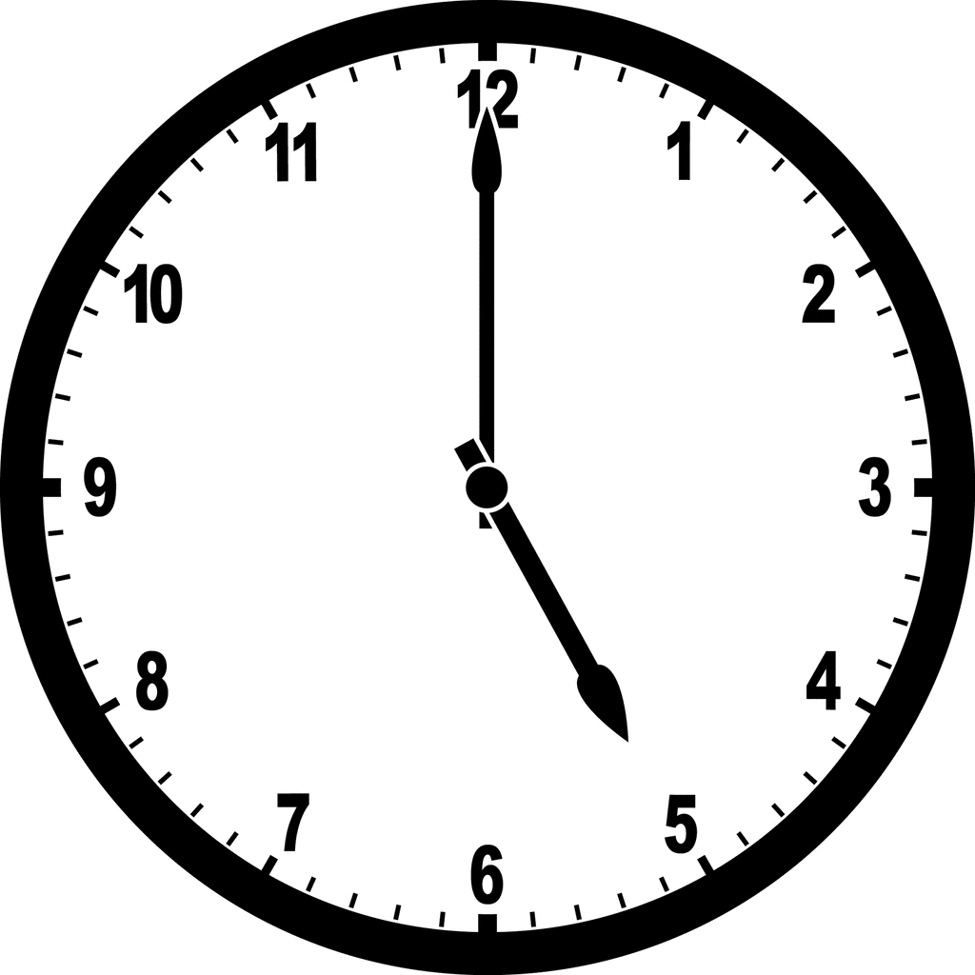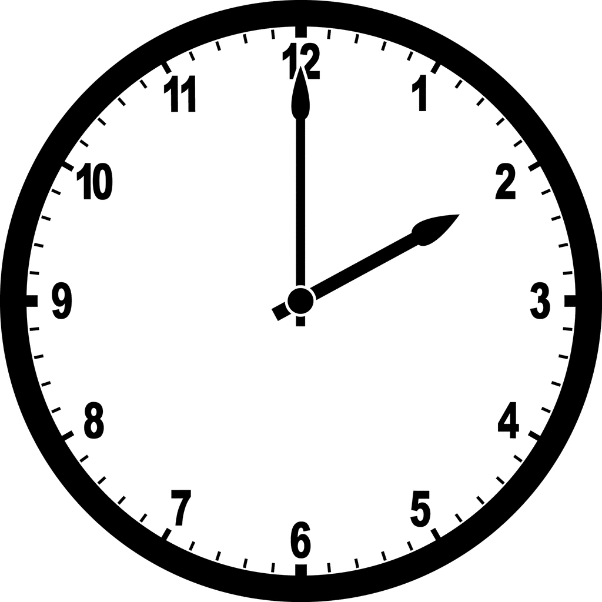

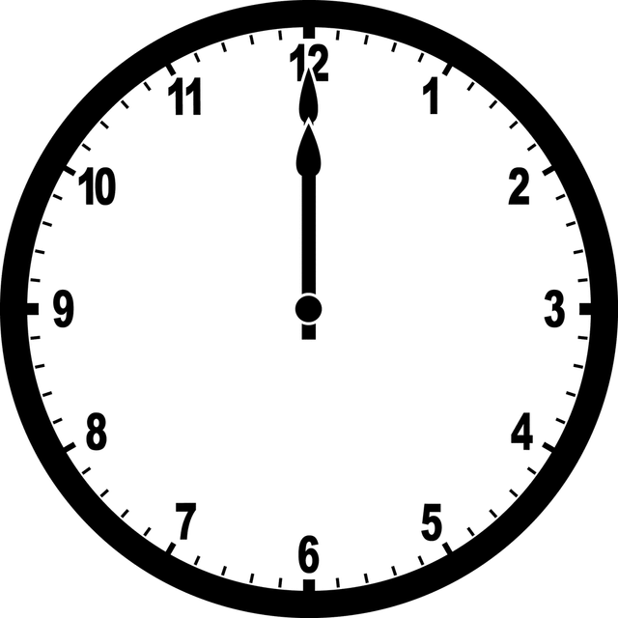**7. Draw the hour hand of the clock to show the given time. [4]**

8: 00

6: 00

**8. Write the multiplication table of 4. [4]**

[4×1= ]

**9. Draw a triangle and square. [4]**

**10. What comes before? [2]**

i. _______6 ii. _______ 9

**11. What comes between? [2]**

i. 5 _______ 7 ii. 9 _______ 11

**12. What comes after?**

i. 8 _______ ii. 6 _______

THE END